• [Star Sabre](https://www.cpcwiki.eu/index.php/Star_Sabre) (2007) ‒ an impressive horizontally scrolling [shoot-'em-up](https://www.cpcwiki.eu/index.php/Shoot_them_Up) that was rated 88% in issue 51 of [*Retro Gamer*](https://www.cpcwiki.eu/index.php/Retro_Gamer) magazine

• [Star Sabre 128K](https://www.cpcwiki.eu/index.php/Star_Sabre) (2009) ‒ an extended version of the same game using 128KB of RAM  
Loading Screen CPC Conversion : [Sylvestre CAMPIN](https://www.cpc-power.com/index.php?page=database&lemot=Sylvestre%20CAMPIN&r3=1&r4=1) alias [Super Sylvestre](https://www.cpc-power.com/index.php?page=database&lemot=Super%20Sylvestre&r3=1&r4=1) alias [Supersly](https://www.cpc-power.com/index.php?page=database&lemot=Supersly&r3=1&r4=1)  
Sound Code and Music : [Julien NEVO](https://www.cpc-power.com/index.php?page=database&lemot=Julien%20NEVO&r3=1&r4=1) alias [Targhan](https://www.cpc-power.com/index.php?page=database&lemot=Targhan&r3=1&r4=1) **MARK HALL TALKS TO PROGRAMMER PAUL KOOISTRA ABOUT LIFE, FILMS, ADVICE, AND HIS AMSTRAD CPC GAME : THE MIGHTY FINE SHOOT-EM-UP STAR SABRE**

**MH: How did you get into programming, was it through friends or did you simply see a game and think “wow, I could do that”?  
PK: Early on in High School my parents bought my brother and I a CPC464... I was interested in learning how to program it from the outset, but later I, along with some of my friends with C64s, decided we. were going to get into making games. We only got as far as making some things in SEUCK, Quill, GAC, and Laser Basic and not much was finished for my part, but I did manage to gain some knowledge of assembly before the 8-bit era came to an end and I put that aside at the time.**

**MH: What Amstrad or other computer system game would you most like to have been involved with back in the day?  
PK: Nothing comes to mind. I don't think I'd want to have been involved with games I enjoyed playing or that impressed me somehow, anyway.**

**MH: Star Sabre is the only CPC game you've ever released, how proud are you of this project? And was there anything you wanted to put in but couldn't due to memory restrictions?  
PK: I'm pretty happy with it, as I largely achieved what I set out to do. - My focus was to try to make a shooter on the CPC at what I considered an acceptable frame rate, with no slow down, good sprite count and collision detection with a little leeway to it. I believe I just about managed that, with the only thing I'm not quite happy with in the end being the sprite count.**

**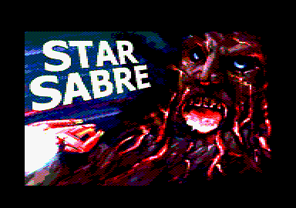  
Oh, no! Oh, Jesus! They've taken over! (I know! - Ed)**

**I had to leave out a few things for memory, specifically a high score table, enemies made of several sprites appearing during a level, and secondary weapon pick-ups for the player. Of course, more generally there's the lack of music and the very limited graphics space, but those were issues I expected from the beginning with targeting 64k and there really wasn't much I could do about them beyond taking something else out.**

**MH: Would you ever do another game, or a sequel maybe?  
PK: A sequel isn't likely. I am thinking about different ideas for other possible games, but I haven't settled on anything yet.**

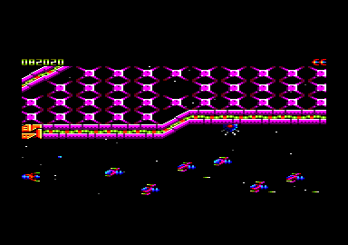

**MH: What advice would you give to anybody attempting to write their own game, especially on the CPC or CPCplus?  
PK: Be prepared for it to take a lot of time! For the CPC I'd have to recommend using WinAPE for development. It's such a great development tool, I almost don't think of it as an emulator any more!**

**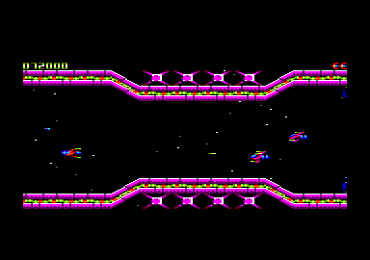  
The monkeys now ruled space; they'd taken over**

**MH: What is the best game you've ever played, across any system?  
PK: Probably Ico. I could name quite a few games for this, as there are some genres and games I just wouldn't compare. But of all the games I've played over the years and just been grabbed by, I think Ico is the one I've had the least misgivings about at the end of it all.**

**MH: Desert island games, what ten games would you take with you?  
PK: Soul Calibur (DC), Contra 3 (SNES), Super Ghouls & Ghosts (SNES), Rez (DC), Oblivion (360), RType 3 (SNES), XCom: Enemy Unknown (PS1), 1942 (Arcade), Timesplitters 2 (GC), and Rygar (Arcade).**

**MH: Some call the CPC the also-ran, but was it really as bad as everyone makes out?  
PK: Yes, it must be since I always get the “wrong” thing! I've got an HD DVD player, plasma rather than an LCD TV, a DC originally instead of a PS2, and (arguably I guess) a SNES instead of a Mega Drive... In fact the only blot on my record for buying against “consensus” was getting a PlayStation after the SNES, but with a new entrant having a marketing campaign like 'Society Against PlayStation', how was I supposed to know?**

**MH: One final question, what is your favourite movie of all time?  
PK: Well, again I wouldn't really say there is one all time favourite, but for the sake of the argument, let's say Aliens.**

## ============================================================================ nterview of Axelay (February 2011)

**Paul Kooistra**, also known as **Axelay**, is the author of [*Star Sabre*](http://www.psytronik.net/main/index.php?option=com_content&view=article&id=74:sabre&catid=41:cpc&Itemid=63) (2007, 2009 for the 128Kb-version), [*Dead On Time*](http://www.psytronik.net/main/index.php?option=com_content&view=article&id=80:dot&catid=41:cpc&Itemid=63) (2010) and [*Sub Hunter*](http://www.psytronik.net/main/index.php?option=com_content&view=article&id=68&Itemid=56) (2011). He is one of the most productive game programmer for the Amstrad CPC. I was curious to know more about him, and he kindly accepted to answer my questions !  
  
At the end of this interview, you will find some bonus materials covering the work of Paul.

**1. Hi Paul ! Can you quickly present yourself ? How long do you program for the Amstrad CPC ? Why choosing "Axelay" as pseudonym ?**



The magazine that get Paul back with Z80 programming

My parents bought my brother and I a *CPC464* when I was in early High School, around '85 or '86, and I began with programming in *BASIC*, then using *GAC*, *Laser Basic and Compiler*, until finally deciding I needed to use assembly to get the results I was after. I didn’t know anyone else trying to learn Z80, but a couple of friends with C64s also liked the idea of trying to make games at the time.  I don’t recall that getting beyond a few discussions, but one of them, **Matthew van Rooijen**, was going to be our graphics artist, so it was pretty cool that years later he did do some cover art for my first two games. :-)  
  
I got a *CPC6128* around '90, but didn’t get much use out of it for long after that, as the last time I coded would have been around '91 or '92, where I had an 80% complete horizontal shooter "of sorts".  After that I didn’t do anything with the CPC, or even think about there still being a scene until 2004 when I started a new horizontal shooter based on my notes from the old one.  Reading about other people in the [Retro Gamer](http://www.retrogamer.net/) magazine making 8 bit games got me to thinking about it again, and after a while I eventually did take the plunge.  
  
For my pseudonym, I'm not sure, as I started using it a while back now!  I think I just wanted to avoid using the name of a CPC game, so I chose "*Axelay*" as it is my second favourite *SNES* shooter.  The *SNES* was the next piece of hardware I had after the CPC.  *R-Type 3* is my favourite SNES shooter but didn’t seem like a very good name. ;-)

**2. You just released Sub Hunter, which is actually a conversion from an existing game on C64. Did you do such a conversion because of already existing graphics ?**

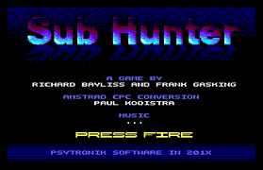

No, it was a combination liking the C64 game, having it proposed as a potential conversion, wanting to have a go at a C64 conversion at some point and thinking that this game appeared to be one I could convert well.  As to why I wanted to do a C64 conversion, I think it's probably just that most of my friends had C64s, so I saw a lot of cases of CPC versions of multi-format games coming off second best for no good reason and got this idea of having a go at one myself.  I also wanted to try out some techniques that appeared to suit the game that I hadn't had a chance to use before.  These were the software scroll and aspects of the sprite code, like trying out some pixel masking.

**3. Still about Sub Hunter, can you tell us more about the technical challenges you faced while creating this game ?**

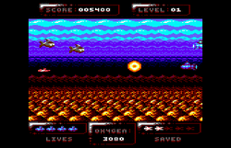

Heh, "the usual". :-)  Mainly going for a fixed frame rate and so finding the right balance between memory and CPU use.  The balancing between those two things was a bit easier for this game because I'd already done some of the same sorts of things with [*Dead On Time*](http://www.psytronik.net/main/index.php?option=com_content&view=article&id=80:dot&catid=41:cpc&Itemid=63) and some of the approaches from that worked here.  That gave me some ball park figures to use when working out sprite counts and sizes, allowing for logic time, score updates and so on.  *Exomizer* was really helpful this time round because of the way the games different graphics were used 'sparingly' between levels.  I haven’t added it all up but I think decompressed there'd be about 48k of game squeezed into 32k.

**4. Which tools do you use to create your programs ?**

*WinApe* for coding and debugging.  For graphics it is primarily *Advanced Art Studio*, but also a bit of work in *Paint Shop Pro* and this dirty little screen converter I wrote that just converts mode 0 screens without worrying about colours and then writes them as amsdos scr files so I can use them in *AAS*.  And as I mentioned I have also used *Exomizer* a lot with this game.  I have another little tool for that which just converts the compressed file into an asm so it's easier to manipulate its’ placement and inclusion with other data.  I convert all the graphics and music into asm files for the same reason.

**5. What is your favorite game between Star Sabre, Dead On Time and Sub Hunter ? The one you are the most proud of ?**

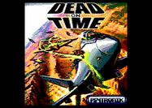

Probably [*Dead On Time*](http://www.psytronik.net/main/index.php?option=com_content&view=article&id=80:dot&catid=41:cpc&Itemid=63).  It would stand to gain the least from 128k enhancement, so feels the closest to everything it could be.  Sub Hunter would be a close second with only a few small things that would benefit from some extra memory, such as high score name entry, sound effects, and difficulty levels.  I'm happy enough with both versions of [*Star Sabre*](http://www.psytronik.net/main/index.php?option=com_content&view=article&id=74:sabre&catid=41:cpc&Itemid=63) but as my first game I was doing a lot of learning while writing them so they both could be better, especially the 64k version, and I hope at some point to have the time to do another horizontal shooter along those lines.

**6. All your games have 64Kb-compatibility. Why is that important to you ?**

The CPC464 was what I started out on, so I like to make games 64k compatible if it's possible.  I've seen a few dismissive remarks about the 464's 'value' in recent years but as far as I'm concerned 464's are CPCs too! ;-)  More seriously, I just enjoy the idea of trying to squeeze as much as possible out of 64k than having all the memory I could want, even if it can be frustrating at times.  It also results in smaller projects with a lower risk I will tire of them before they are completed.  I got very close to putting development of the 128k [*Star Sabre*](http://www.psytronik.net/main/index.php?option=com_content&view=article&id=74:sabre&catid=41:cpc&Itemid=63) on hold at one point near the end, as I just got so sick of it!

**7. Your games are released under the Psytronik Software label. What are the benefits ?**

[](http://www.psytronik.net/)

I guess having the label helps the games feel more like 'real' commercial releases, but mainly it's because I like having a physical version of my game at the end of it all.

**8. Still about Psytronik Software label, do they provide facilities to sell games for retro-platforms ? Without giving us precise numbers, did the games sell well ?**

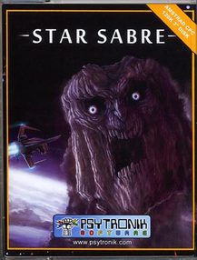

Yes, this is the main reason for using the label, to acquire a physical copy of my game.  I'm not that interested in trying to design/produce one myself, or managing sales or a proper website, so having **Kenz** do all that through the [Psytronik](http://www.psytronik.net/) label saves me from having to do those things, and I get a physical media version of the game that is much classier looking than anything I would be likely to come up with.  
  
As to sales figures, the two previous games sold around a dozen or so.  I don’t know what sort of figures would amount to selling well, I didn’t have any particular expectations, though the original 64k version of Star Sabre sold a little better.  Of course, the [Psytronik](http://www.psytronik.net/) releases are also more expensive than that first [Cronosoft](http://cronosoft.orgfree.com/) release, so it's hard to directly compare their sales.  The cool thing to me though is that they were able to be published on original media at all.

**9. Will Sub Hunter be your last Amstrad CPC project ?**

Short of a zombie outbreak or something similarly inconvenient, I hope to work on a couple more yet! ;-)

**10. Do you have interest also in other retro-platforms ? from a programmer-view and/or user-view.**

A little, yes.  I'm always interested to see what new stuff people are coming up with on other platforms as well, but in terms of other home computers I guess mainly the C64 as that's the only other platform that was around at the time where I grew up, so I don’t really have much of a reference point for the other systems.  Of the new C64 games I’ve seen in recent years, [Knight'n'Grail](http://psytronik.blogspot.com/2009/04/quest-for-holy-grail.html) would have to be my favourite.  
  
I'm not programming on any other platform currently.  I did have a bit of a go at some assembly on my brother's Amiga in the early 90's (just scratched the surface) and sometimes I think it might be fun to follow up on that too one day.  I don’t think that I'll be doing that any time soon though, for now I have enough ideas I'd like to try on the CPC.

**11. Do you follow Amstrad CPC's community life ? What are the productions you enjoyed discovering lately ?**



I try to keep up with what's new, though I only remember to check the non-English sites occasionally.  I'm most interested in new games that show some polish or attention to detail, so [Orion Prime](http://orion.cpcscene.com/) is the stand out there, though I'm afraid I haven’t got that far in it yet because I always *think* I'll enjoy a good point and click type adventure until I actually play one to the point where I get stuck!  There has also been a lot of very polished puzzle games in recent years, from [Blue Angel](http://cpcfreak.cpc-live.com/) and [Color Lines](http://www.cpc-power.com/index.php?page=detail&num=4567) last year, back to [Groops](http://www.cpc-power.com/index.php?page=detail&num=2369) and nearly every one released in between, has been really nicely put together.  Again, puzzle games aren’t really a genre I get into much, so as much as I admire the work that's gone into these games I haven’t tended to play many of them for more than a few days after release.

**12. Finally, this is free topic for you : tell us what you want us to know ! (or not :)**

I didn’t imagine that starting to make a new game for an old computer would turn out the way that it has, that’s for sure.  Strange thing is it turns out to be oddly compelling!  So I'd just like to say thank you to everyone in the CPC (and retro!) community for the support they've shown for my games, and to everyone in the scene for their own productions or contributions, be it through games, demos, tools, websites and everything else that keeps the old platforms alive.  But I'd particularly like to thank Targhan, Super Sylvestre, Tom&Jerry, Matt and Kenz for spending so much of their own time getting involved in my follies! :-)

**Conclusion**

Well, this interview gave us a nice overview about you, and your work. Thank you a million Paul ! We wish you all the best for your next coming Amstrad CPC projects.